Spike: Task 19
Title: Message Systems
Author: Mohamed Shafi Uzman Fassy, 102608927

Goals / deliverables:
The goal of this spike task is demonstrate my ability to create a foundational message based interaction system for games where it allows entities such as players to interact with other entities such as a chest for example and communicate using messages while enabling actions to change states of entities.

Besides this report, what else was created?
- Code files in see COS30031-2023-102608927\19 - Spike - Messaging_ Annoucements and Blackboards\MessageSystem\MessageSystem

Technologies, Tools, and Resources used:
List of information needed by someone trying to reproduce this work.
- Visual Studio 2022 Community Edition
- GitHub
- The use of C++ Documentation - https://en.cppreference.com
Tasks undertaken:
- Creating a New Project using Visual Studio 2022
- Creating a message structure to encapsulate communication.
- Creating a message dispatcher class to handle registration listeners.
- Creating a base entity class to create other child entity classes.
- Compile and test code.
What we found out:

Implemented Message Class
I created the message class to handle sending messages between entities where they carry details such as the sender, the message type and the associated data which is not a complex method but ensures that the functionality works when encapsulating the basic unit of communication.
Implemented Message Dispatcher Class
The Message Dispatcher Class basically manages the entire messaging system as its main role is to handle the messages as it ensures that messages are routed to the appropriate registered entities and is designed to be modular and ensures that the game entities are decoupled from each other so that is scalable and reusable.
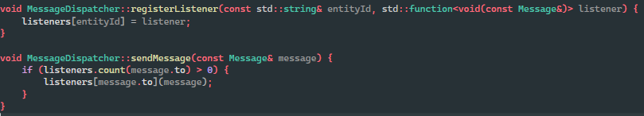
Implemented Entity Class
I created the entity base class so that it can serve as parent class to inherit from to create game entities such as player and chest so that we would receive and send messages when entities interact with each other.
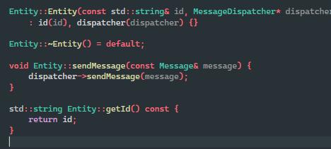
Implementing Child Entities
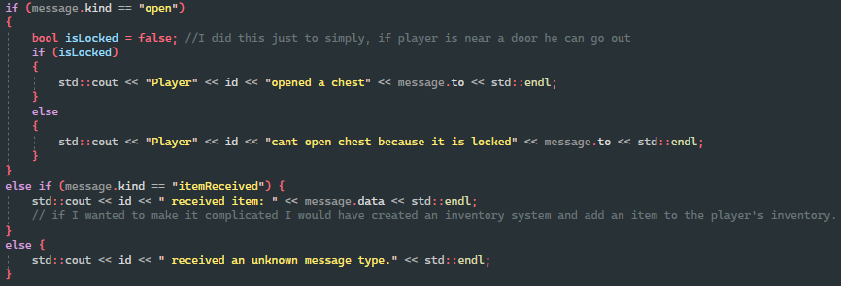
Therefore, using the base entity class we can create two entities called player and chest to simulate a game world interaction where they can exchange messages to simulate some action such as player opens a chest and receives an item.
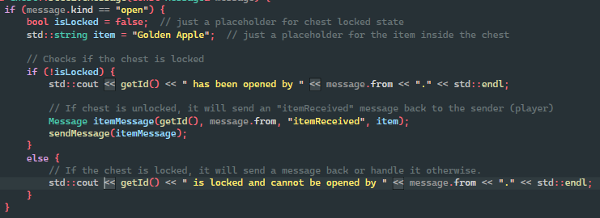
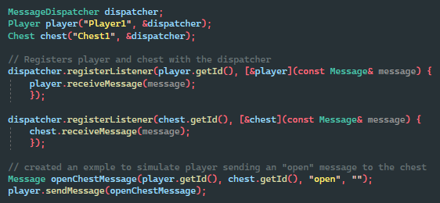
Finally, we can bring it together in the main loop to initialize the entities and message dispatcher to demonstrate the system where it simulates the example of player opening the chest and receiving an item that was hardcoded.
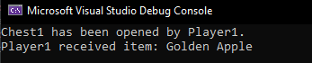

Open issues/risks

Some issue this implementation faces would be the current synchronous messaging system that can sometimes not scale well when we have multiple entities or any complex interactions.

Recommendations
To look into asynchronous messaging systems that improve scalability and also some extra implementations such as to enhance the robustness of message handling for more complex interactions.

